**Setting up and performing operations in Grafana**

__________________________________________________________________

1. Download and install Grafana.

wget <https://dl.grafana.com/oss/release/grafana_6.2.2_amd64.deb> sudo dpkg -i grafana_6.2.2_amd64.deb

1. To start grafana, enter the following command in the terminal

sudo service grafana-server start

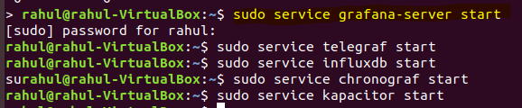

1. Start Grafana using the aforementioned command and then go to “<http://localhost:3000/>”.

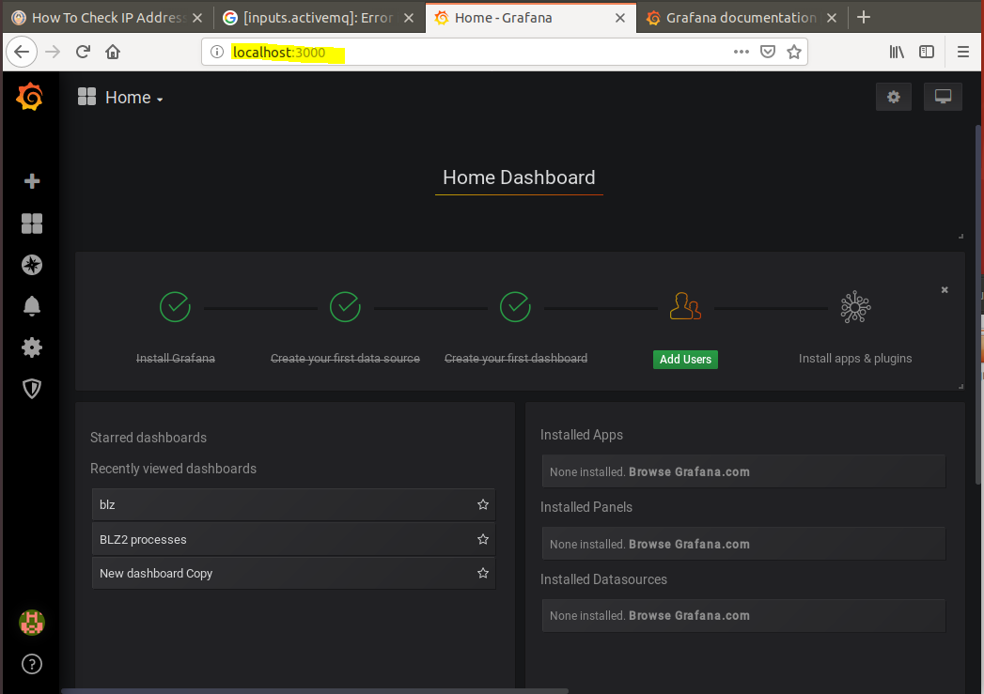

1. Click on “Create your first data source”.

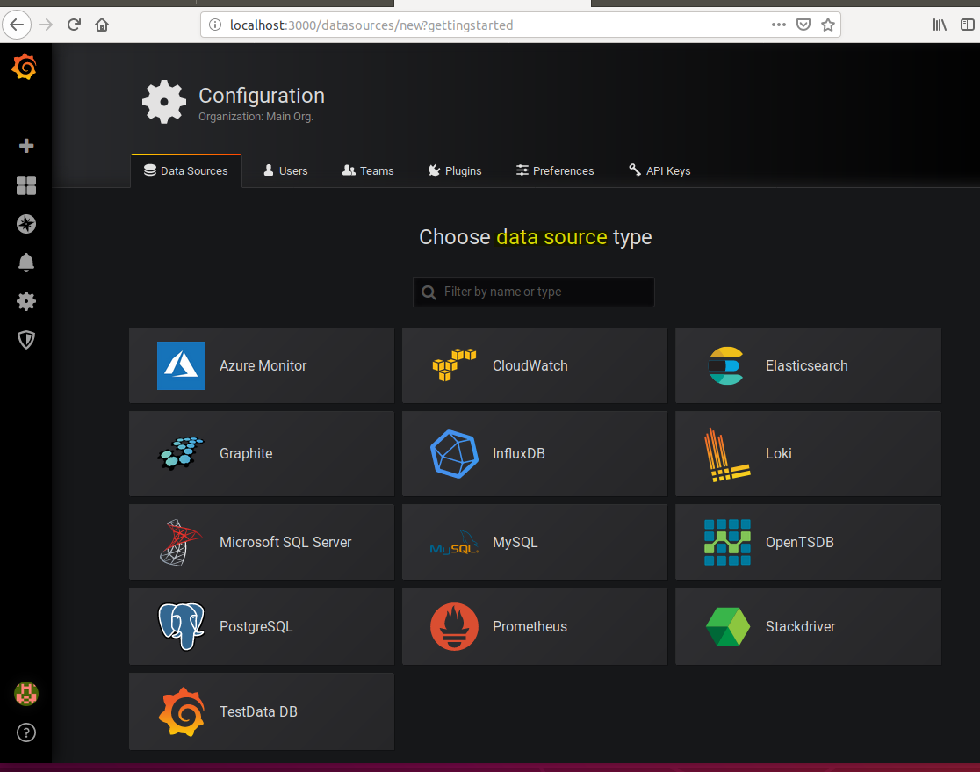

Select InfluxDB

1. Configure data source settings as per requirement. In my case i did not opt for any password or validification. Make sure that the url has been entered and specify database name.

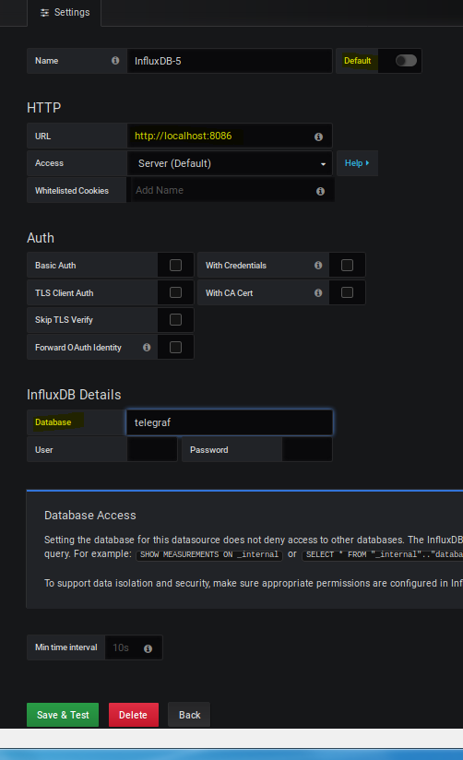

1. Create a new dashboard by clicking on the “+” sign and specify dashboard name.
2. Add a ***panel***, select ***“convert to row”*** .

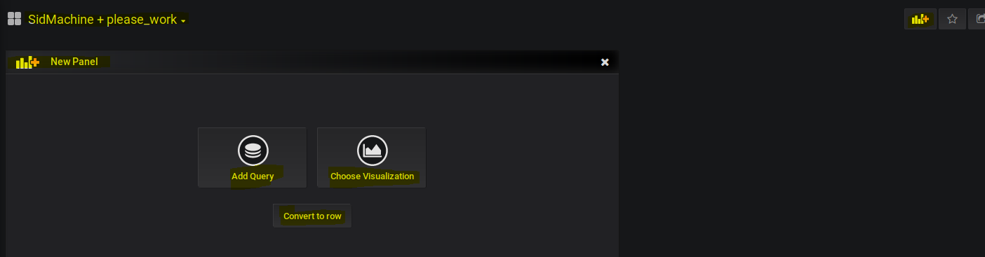

1. Specify a row title

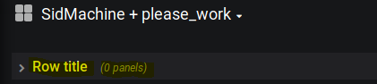

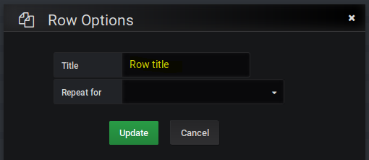

1. Create a new panel. Select ***“Add Query”***.
2. Specify the datasource and then select the measurement and specify the host name. Select a field from the measurement and use “***math***”to generate better visualizations. Generate an alias (Type in the field name).

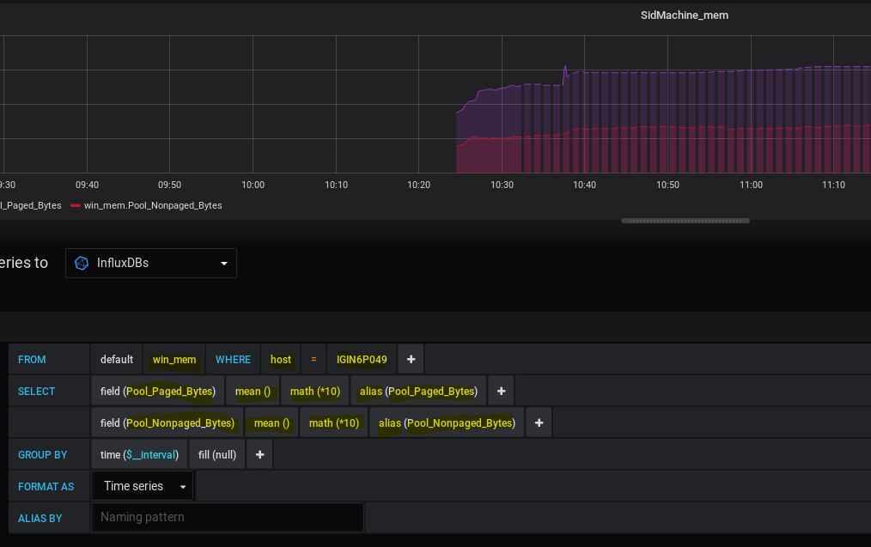

1. To generate more fields click on the “***+***” and select field.

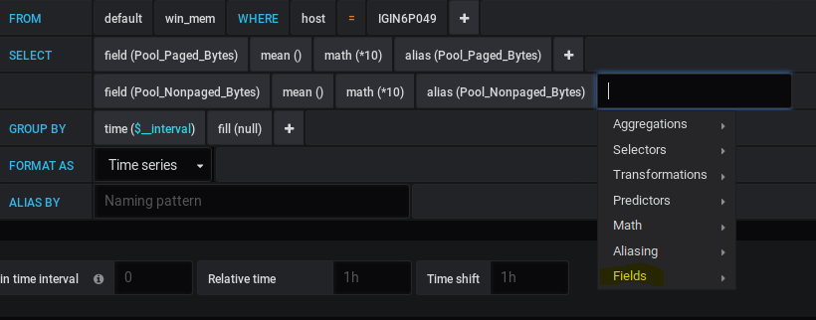

1. Click on the visualizations icon to specify the visualization settings.

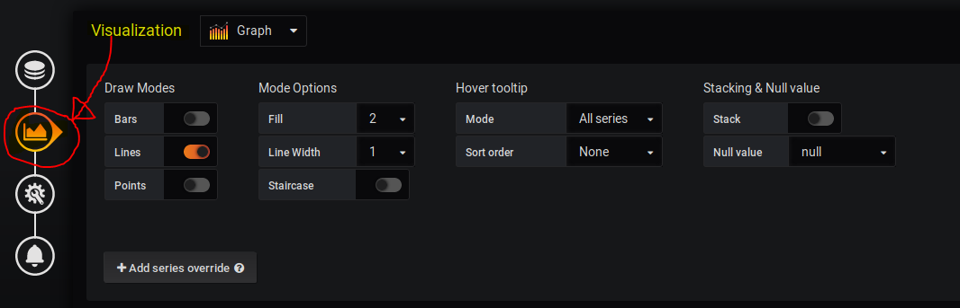

1. From the drop down menu, select the type of visualization.

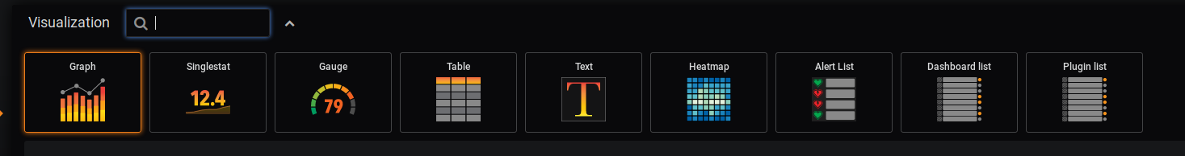

Alter the other parameters as per the requirements.

1. Similarly, create more panels and design the dashboard in order to make it more efficient for viewing the realtime data from all of your servers and datasources.
2. The following is the sample dashboard designed by me.

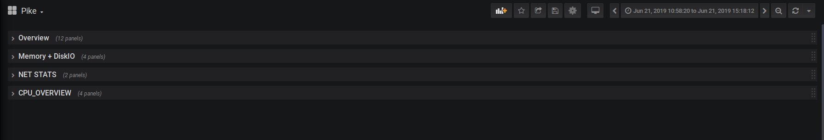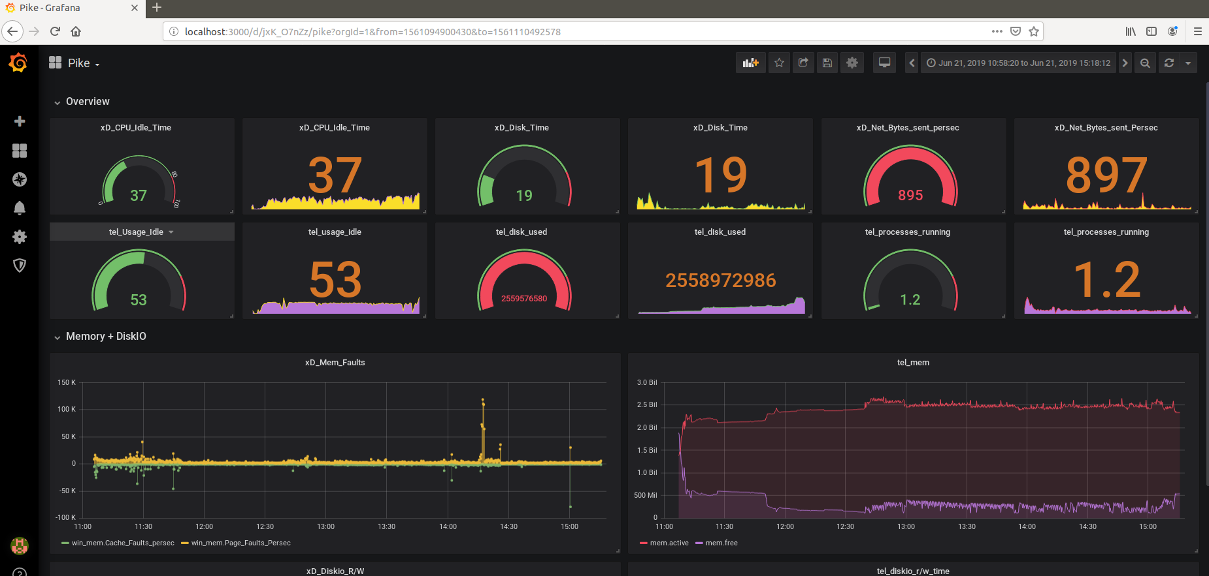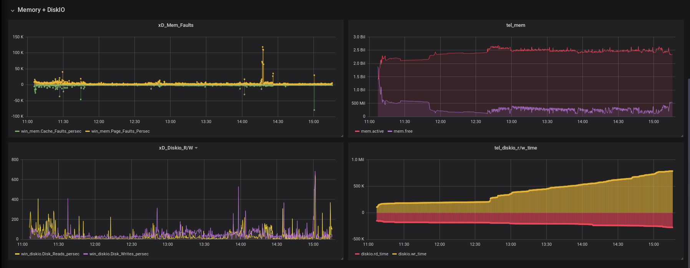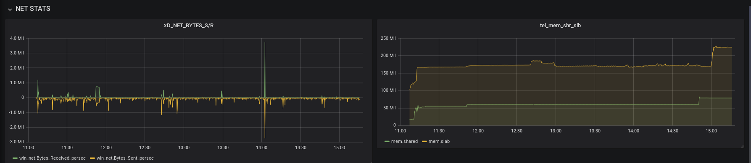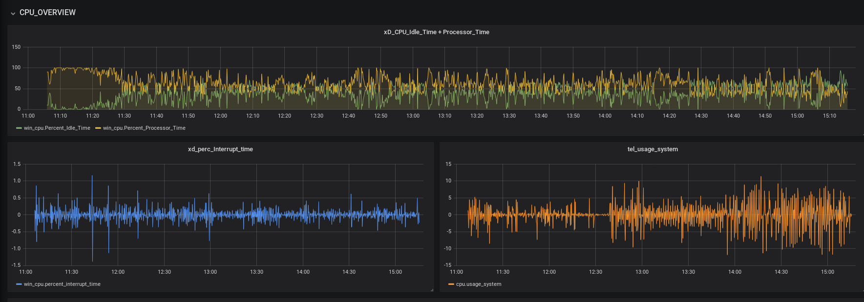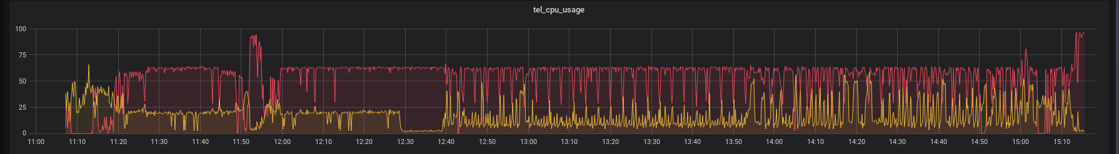

1. In order to generate alerts on grafana, select the “*alert*”icon and click on “*notification channel*” from the menu.

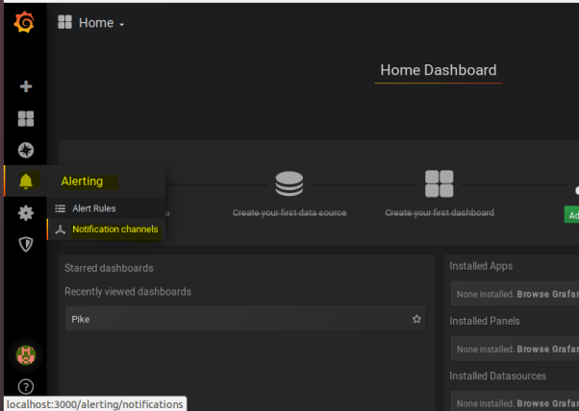

1. Select the “*Add Channel*” icon.

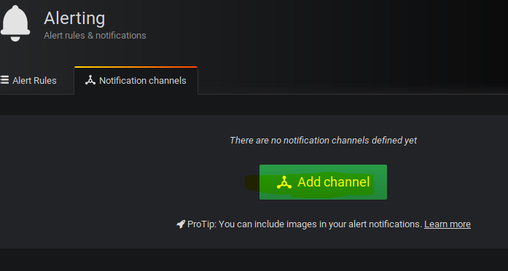

1. Specify a channel name and select the type of alert.

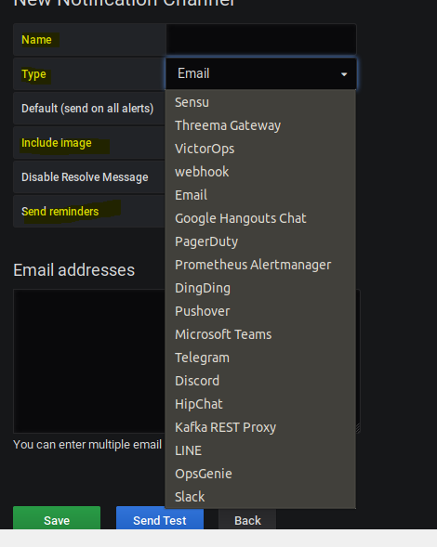

1. Go to a pannel in your dashboard and select the edit option. Click on the “*alert*” icon and select the “*add alert*” option.

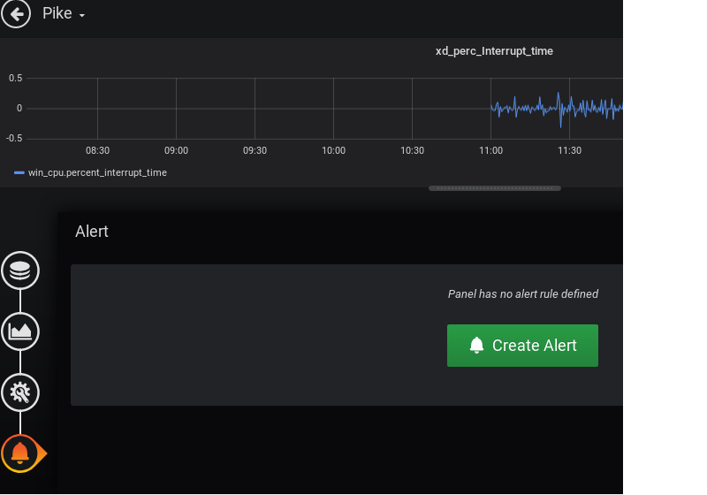

1. Specify the alert parameters

